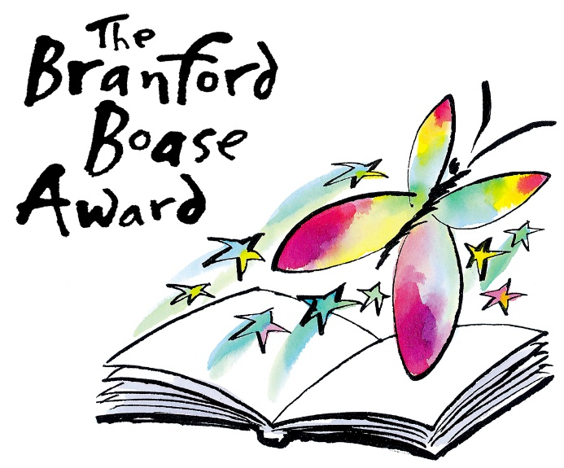

October 2025

Branford Boase Award 2026: submissions open

Submissions are now open for the Branford Boase Award 2026. Publishers are invited to make their submissions by the closing date, midnight Friday 28 November 2025.

The Branford Boase Award was set up in the memory of award-winning author Henrietta Branford and her editor Wendy Boase. The Award is made annually for the most promising book for children of seven and upward by a first-time novelist. Uniquely, it recognises both the author and editor of the winning book.

With its emphasis on the craft of writing and the crucial role played by editors, the award highlights and promotes outstanding writing for children. Now in its third decade, it is still the sole award to credit the work of editors in supporting new authors and ensuring their work is the best it can be. Being shortlisted for the award is a sought-after accolade and winning authors and editors are recognised as setting standards in publishing excellence.

The author may have published other books in another genre - for example, poetry or a picture book - but eligibility for the prize requires that this is their first novel for children. Publishers are required to check that all books submitted are first novels for children and should confirm that with the authors prior to submission.

Previous winners of the prize include Frances Hardinge and her editor Ruth Alltimes for Fly By Night (2006), Maisie Chan and her editor Georgia Murray for Danny Chung Does Not Do Maths (2021) and Christine Pillainayagam and her editor Leah Thaxton of Faber for Ellie Pillai is Brown (2023). In 2024 it was awarded to Nathanael Lessore and his editors Ruth Bennett and Ella Whiddett for Steady For This. The 2025 winners are Margaret McDonald and her editors Alice Swan and Ama Badu for Glasgow Boys.
Eligible titles must be published between 1 January and 31 December 2025. The authors should live and work in the UK.

The Branford Boase Award is delivered in partnership with the Authors’ Licensing and Collecting Society (ALCS) and sponsored by Walker Books.

The submission form and full criteria can be found at https://branfordboaseaward.org.uk/

For further information contact:
Andrea Reece, Administrator Branford Boase Award
E: andrea.reece@zen.co.uk T: 07807893369
www.branfordboaseaward.org.uk

Media enquiries to:
Andrea Reece
E: andrea.reece@zen.co.uk T: 020 8889 1292/ 07807893369

